**Problem 1:**

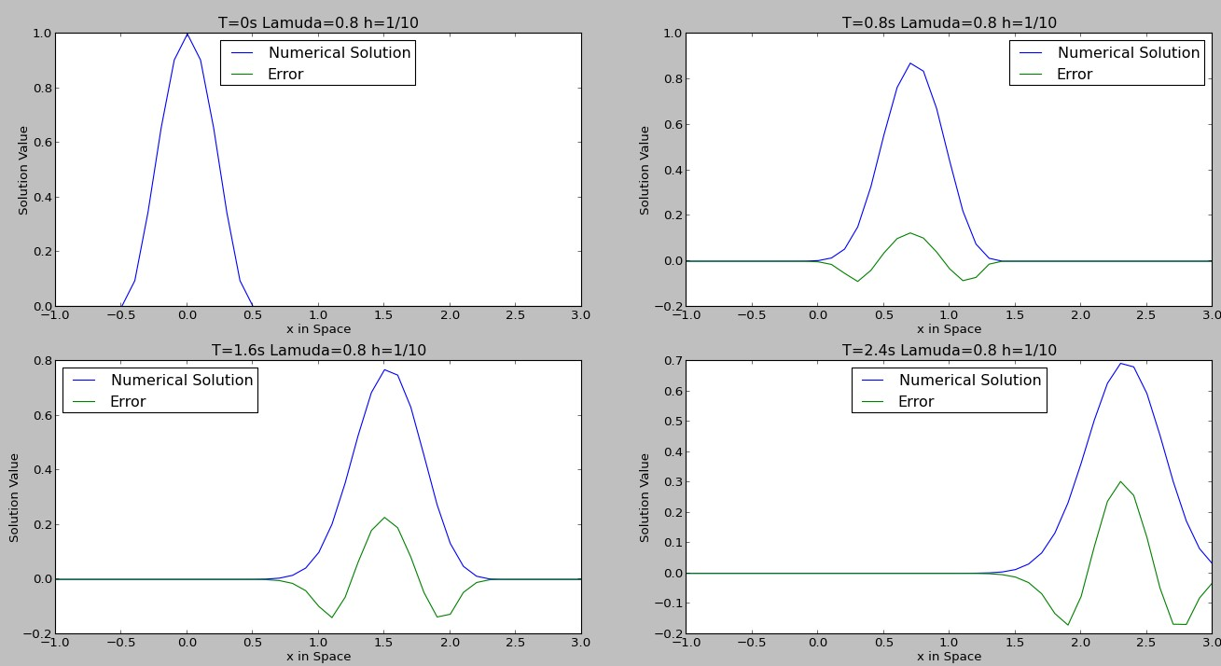**A) FTBS with Lamuda=0.8**

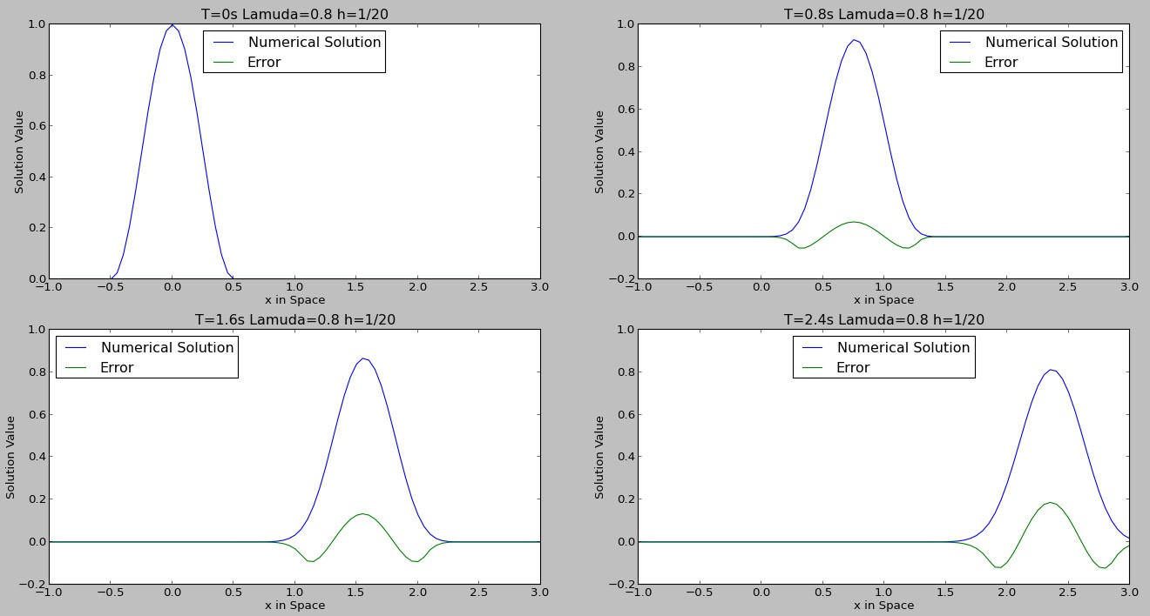

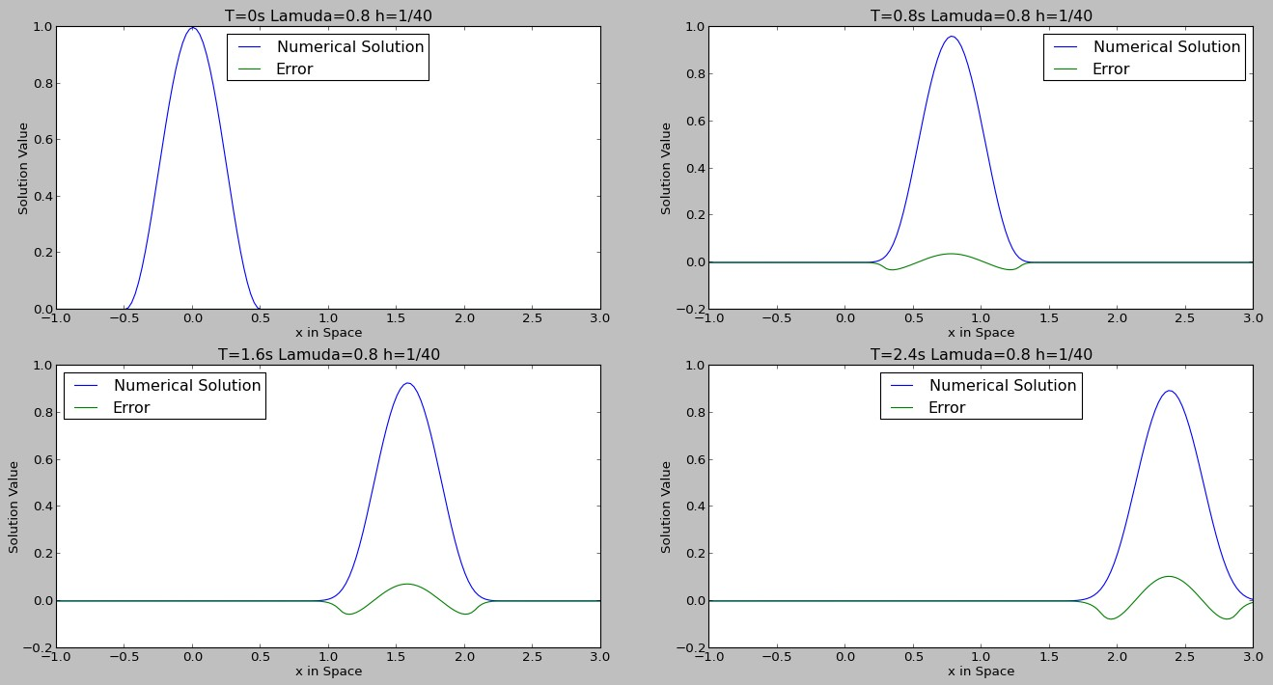

From Figures we can see that the scheme is convergent since the numerical solution is approaching exact solution as error reduces . Also, with a smaller h, the error is reduced.

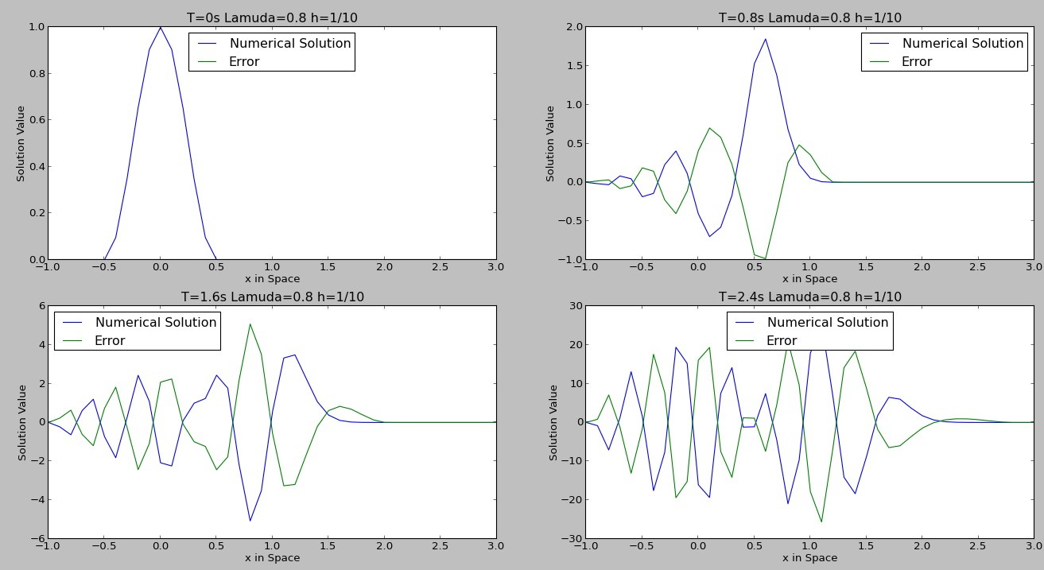**B) FTCS with Lamuda=0.8**

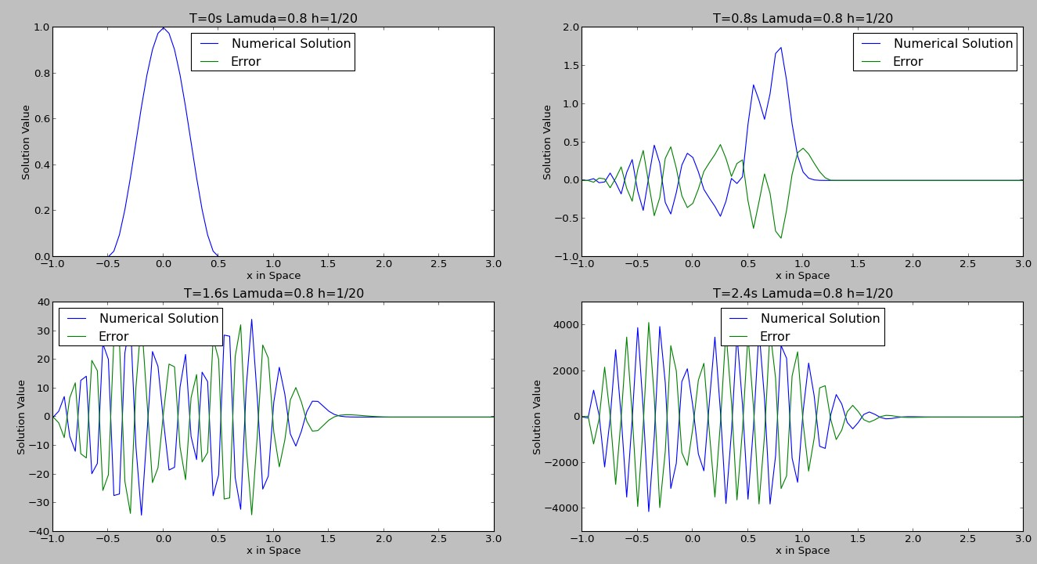

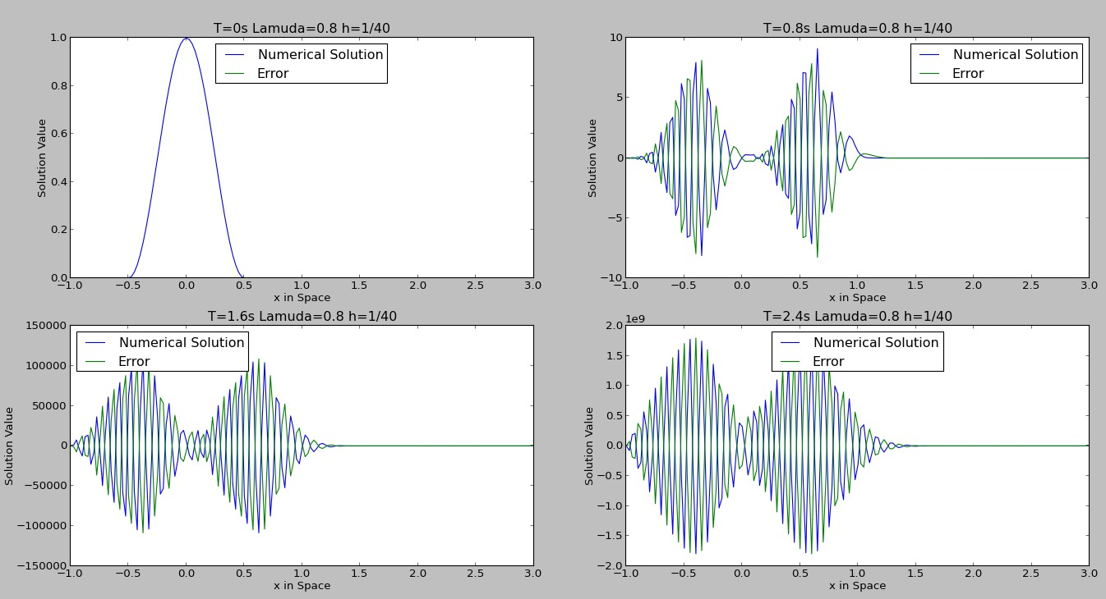

From the Figures above, we can see that as h and k goes to 0, the numerical solution blows up and the error is blowing up. Therefore the scheme is not convergent. Also, the error is not reducing as h reduces.

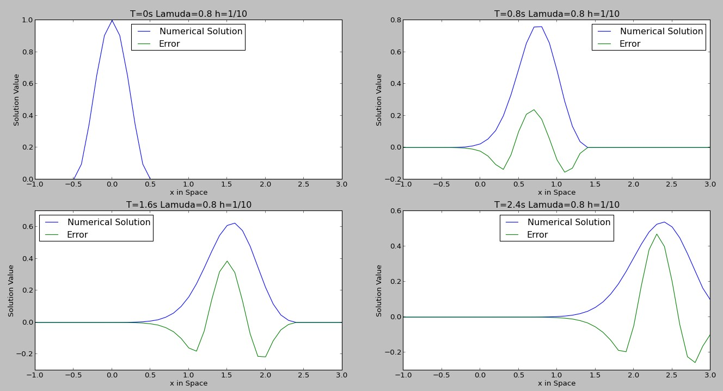**C) i) Lax-Friedrich with Lamuda=0.8**

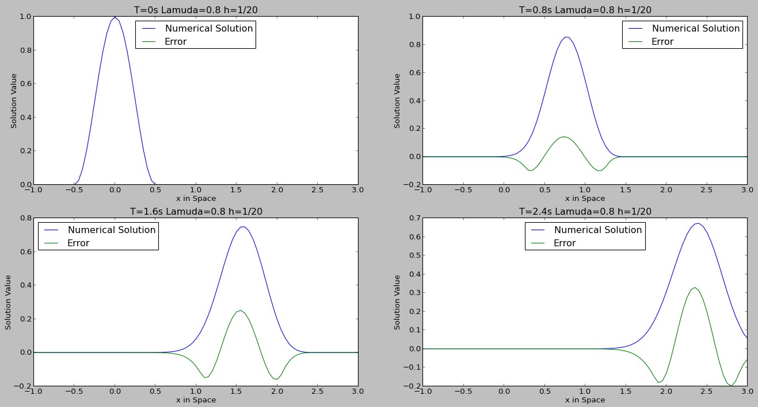

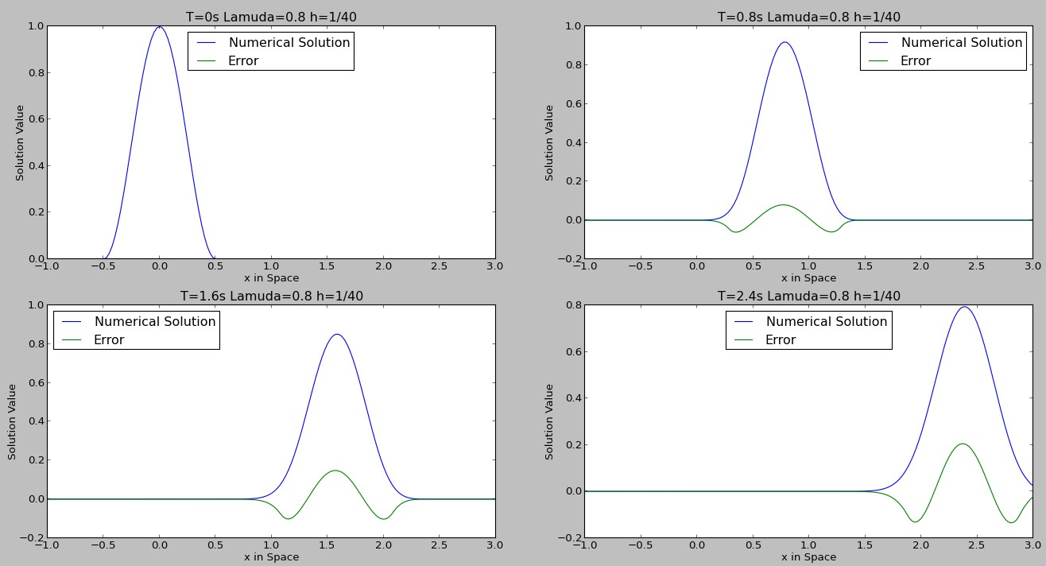

From Figures we can see that the scheme is convergent since the numerical solution is approaching exact solution as error reduces. Also, with a smaller h, the error is reduced.

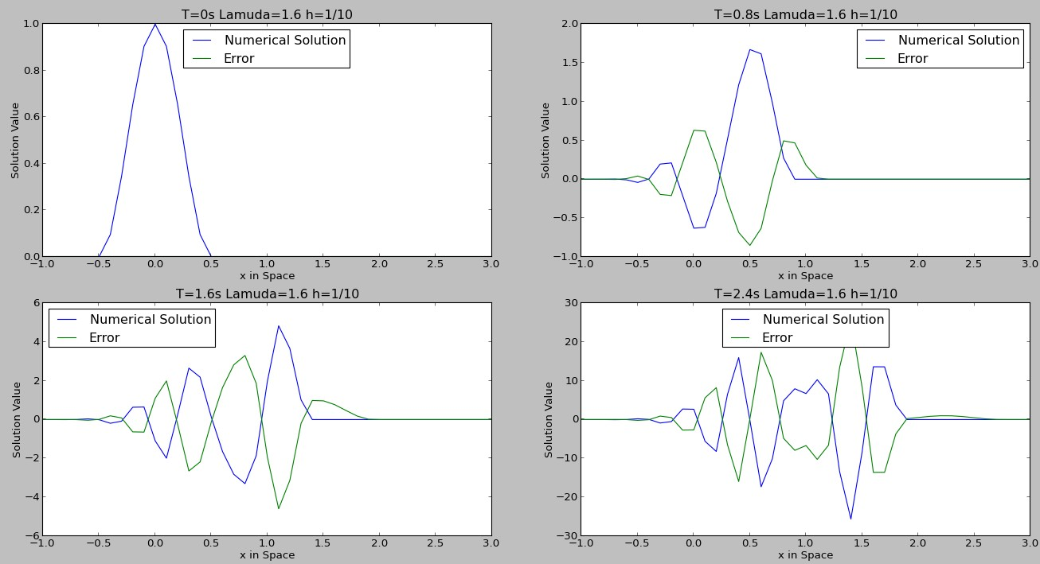**ii) Lax-Friedrich with Lamuda=1.6**

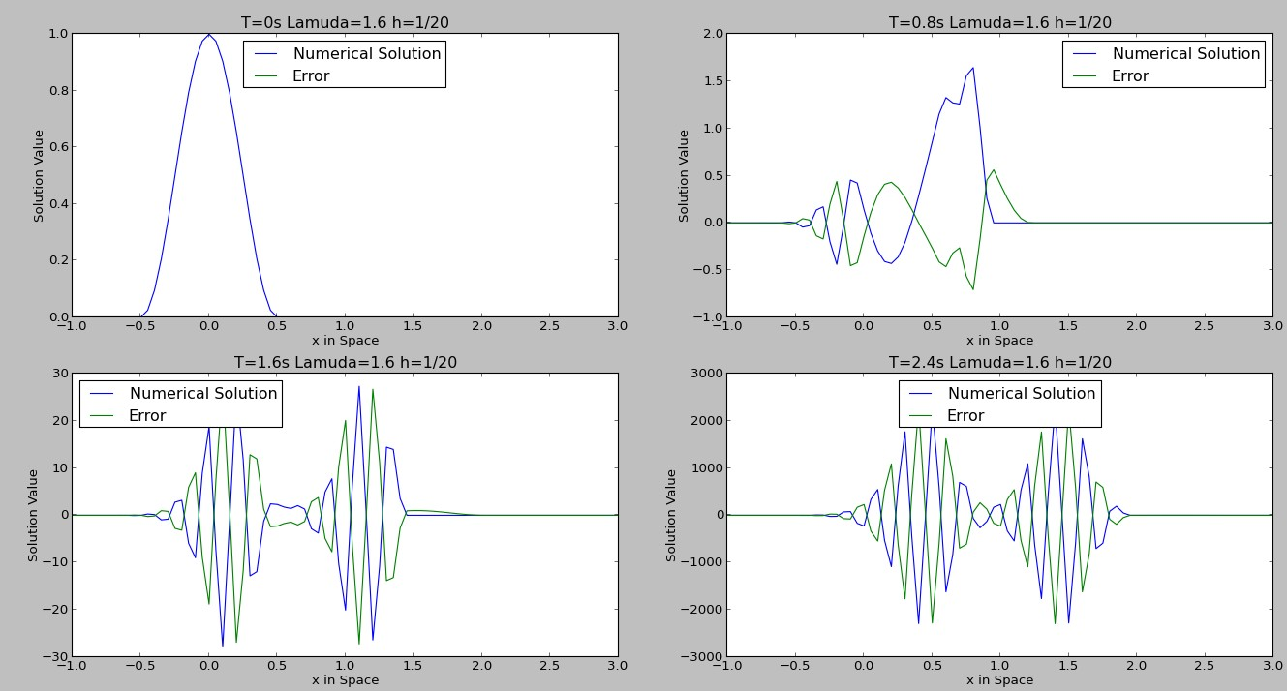

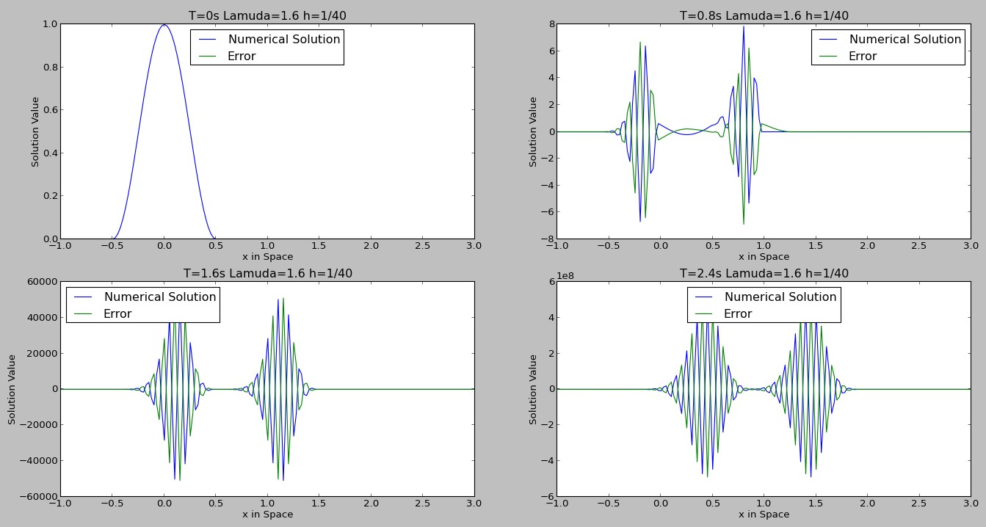

From the Figures above, we can see that as h and k goes to 0, the numerical solution blows up and the error is blowing up. Therefore the scheme is not convergent. Also, the error is not reducing as h reduces.

**D) LeapFrog with Lamuda=0.8**

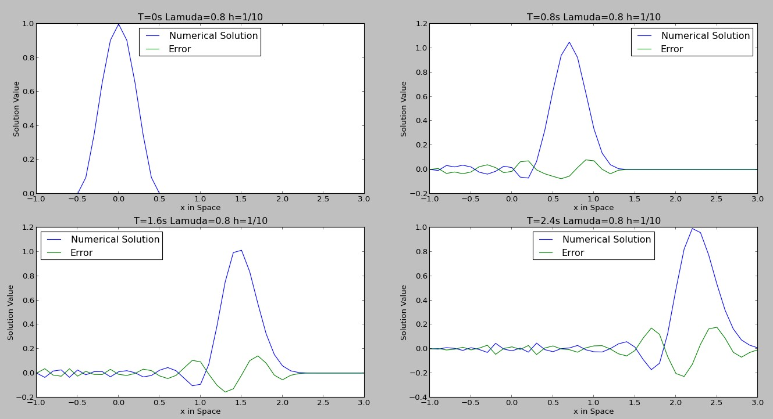

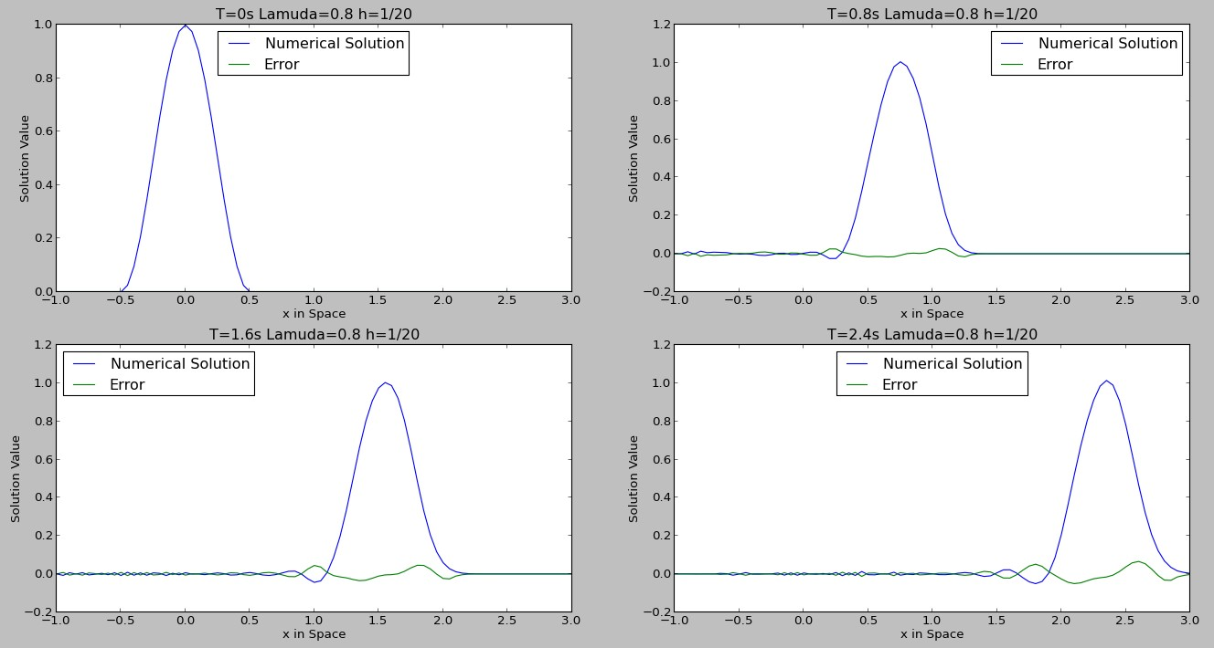

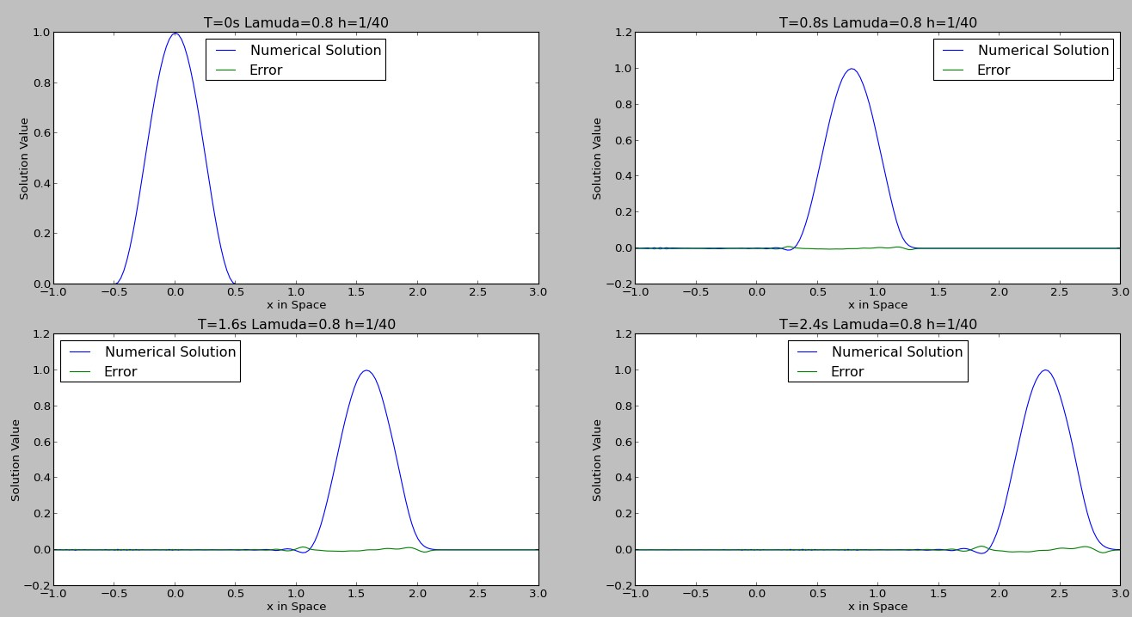

From Figures we can see that the scheme is convergent since the numerical solution is approaching exact solution as error reduces. Also, with a smaller h, the error is reduced.

**Problem 5:**

1. **FTBS with Lamuda=0.8**

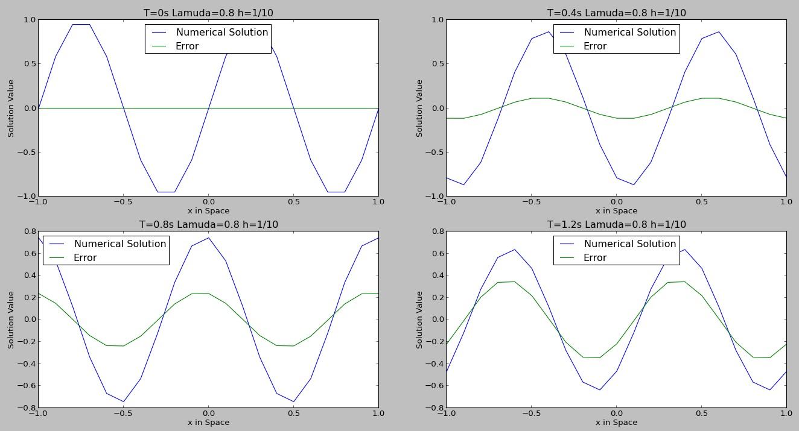

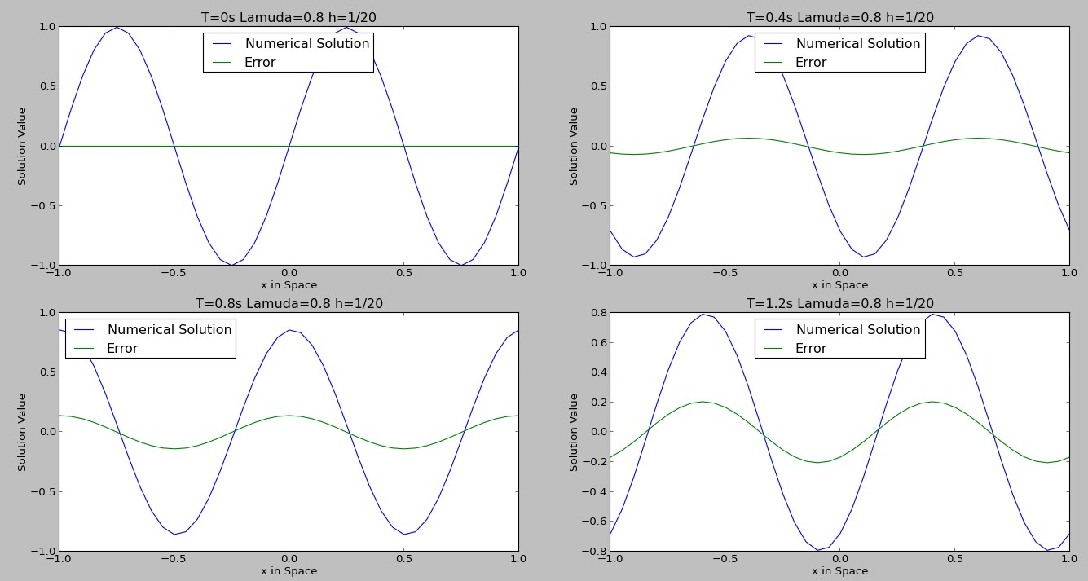

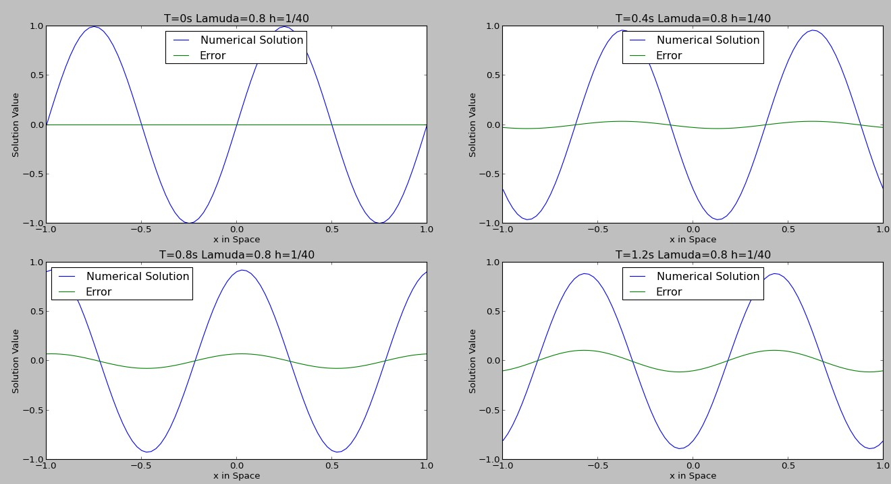

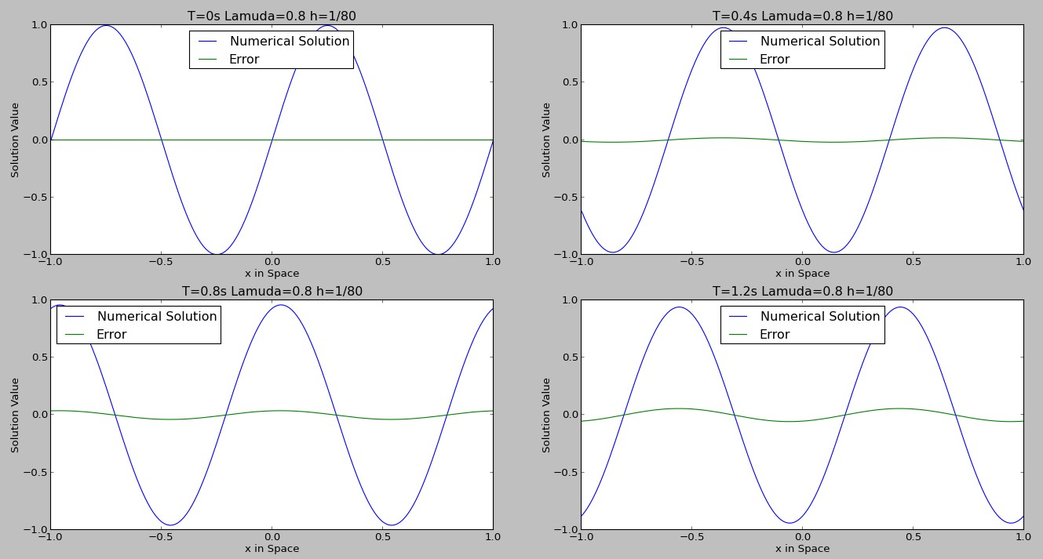

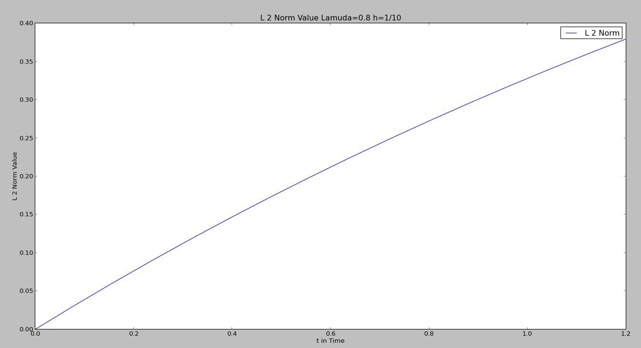

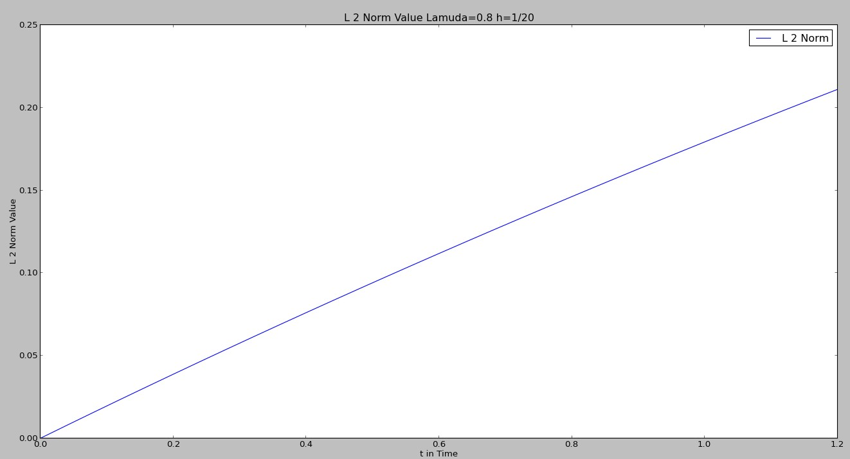

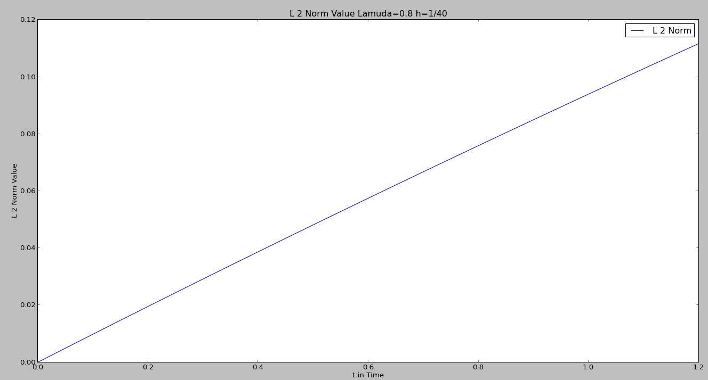

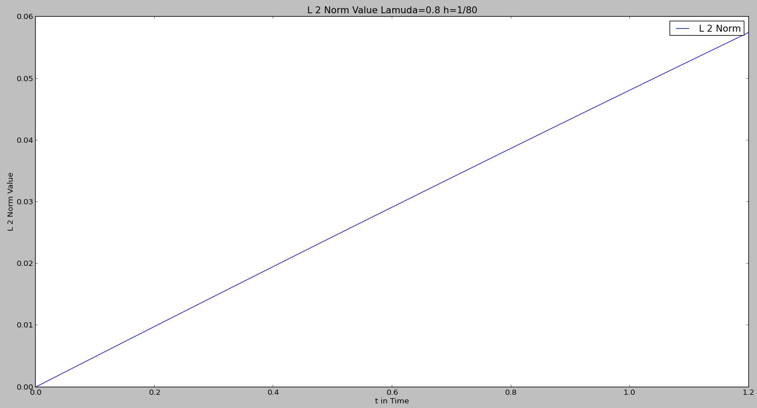

|  |  |  |  |  |
| --- | --- | --- | --- | --- |
| The value of h | 1/10 | 1/20 | 1/40 | 1/80 |
| Max L2 Norm | 0. 37987241 | 0.21125922 | 0.11173705 | 0.05750431 |

|  |  |  |
| --- | --- | --- |
| The Value of h | Error (At time 1.2s ) | Order |
| 1/10 | 1.51 |  |
| 1/20 | 1.17 | 0.36 |
| 1/40 | 0.87 | 0.43 |
| 1/80 | 0.63 | 0.46 |

From the chart we can see that the accuracy order is tending towards 1.

1. **Lax-Wendrof with Lamuda=0.8**

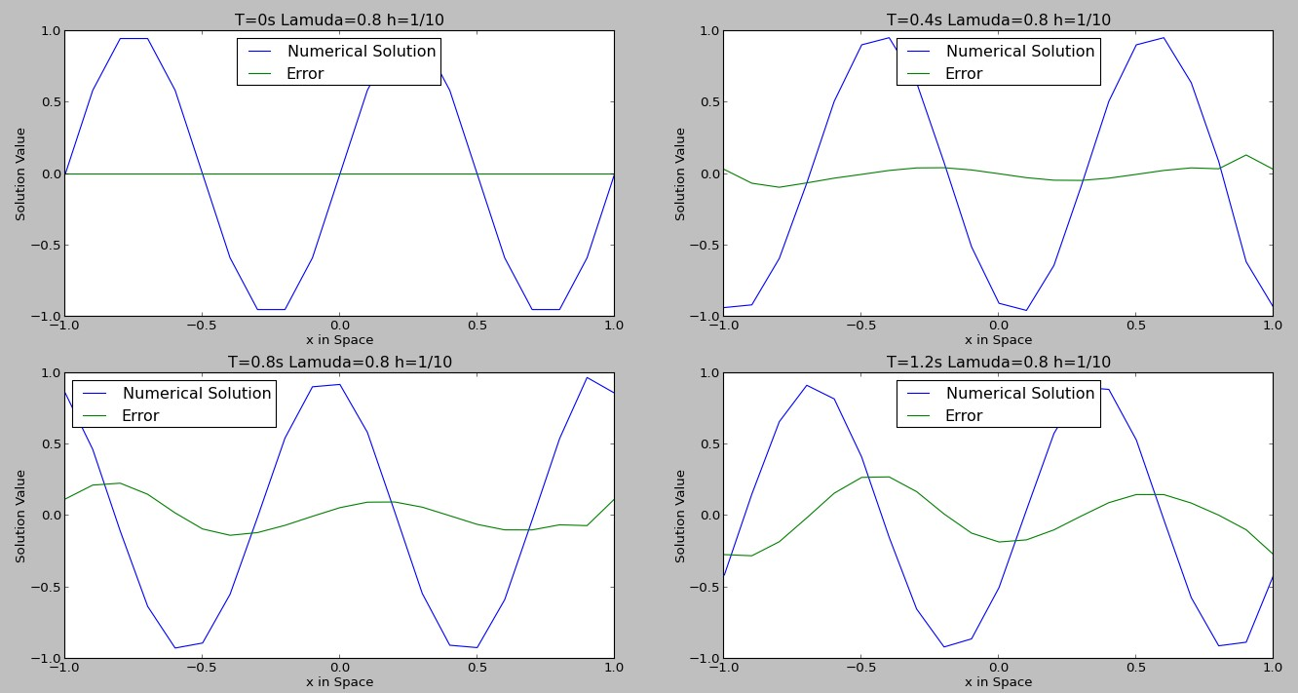

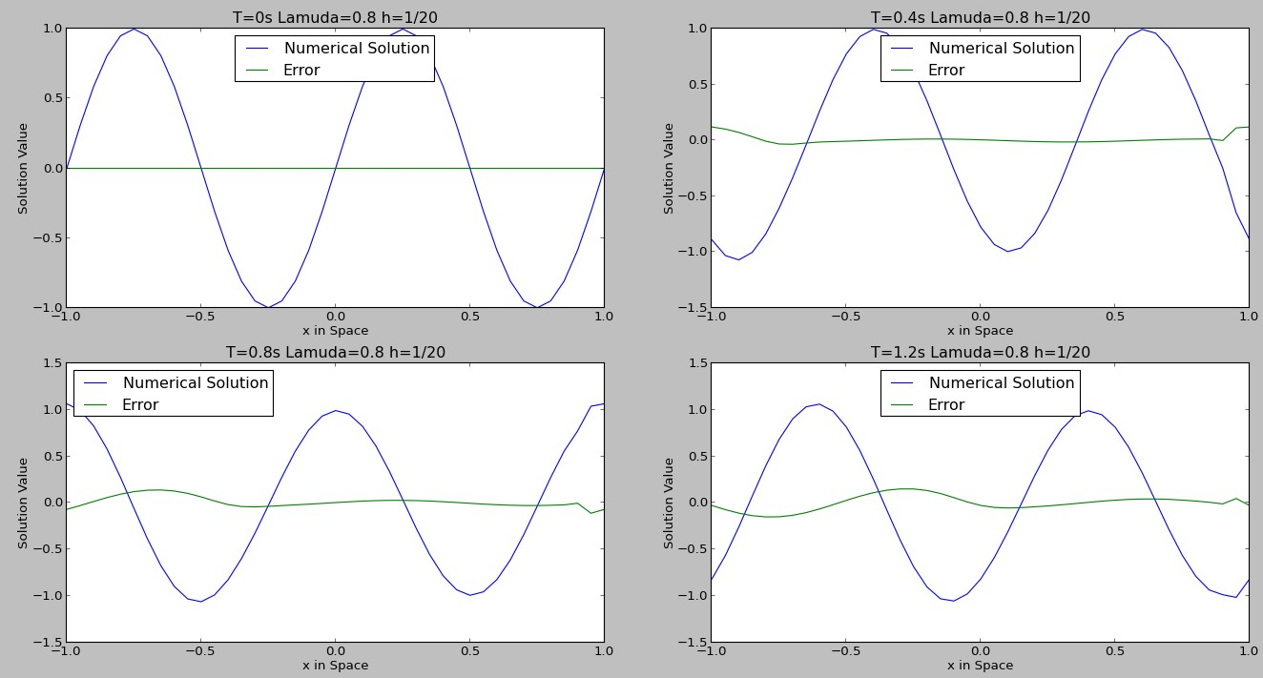

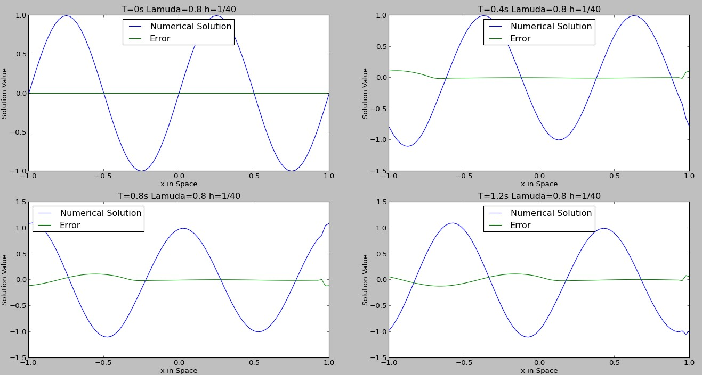

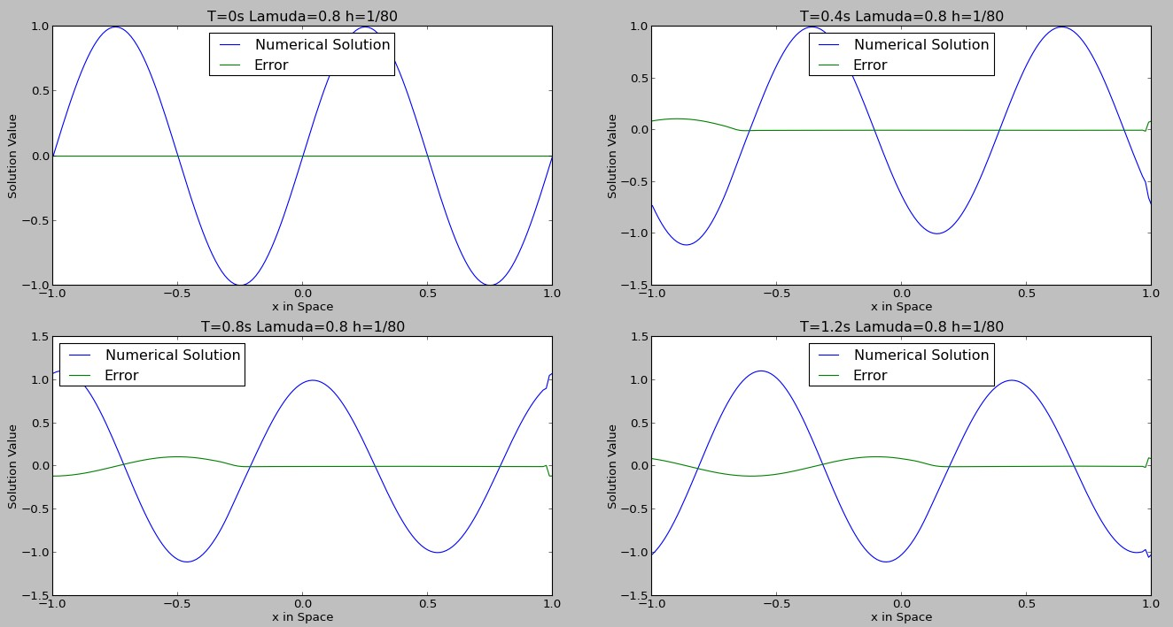

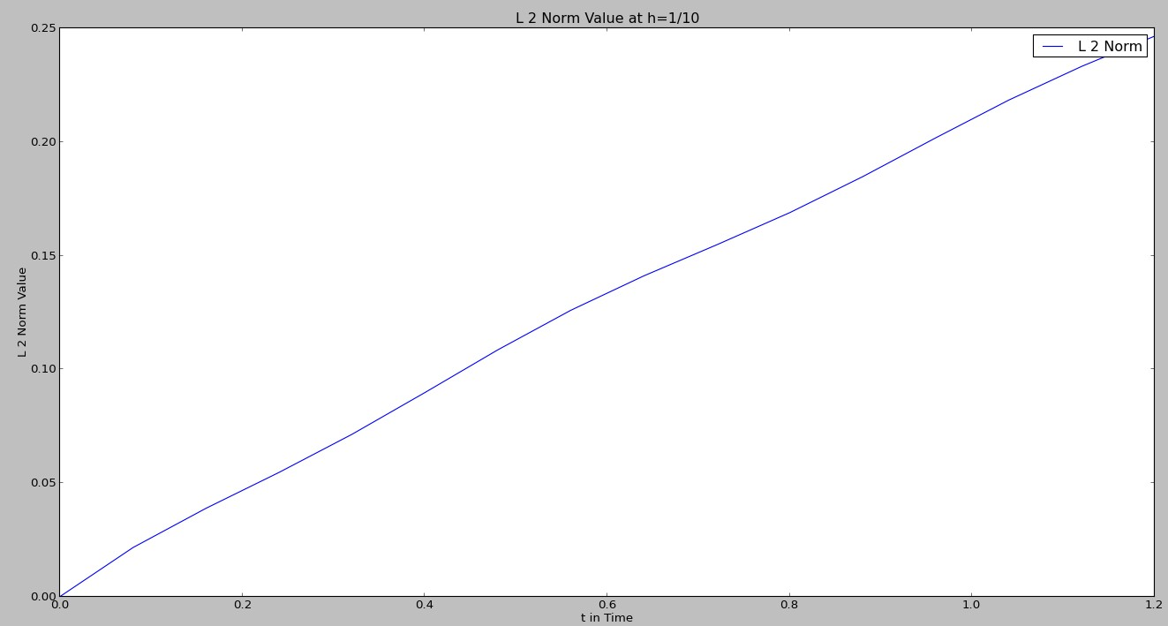

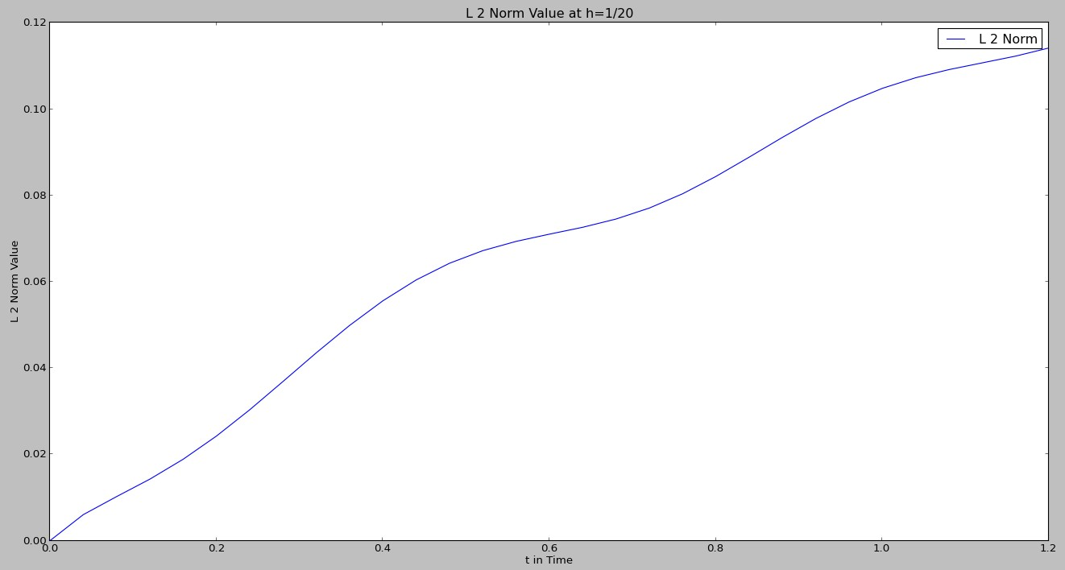

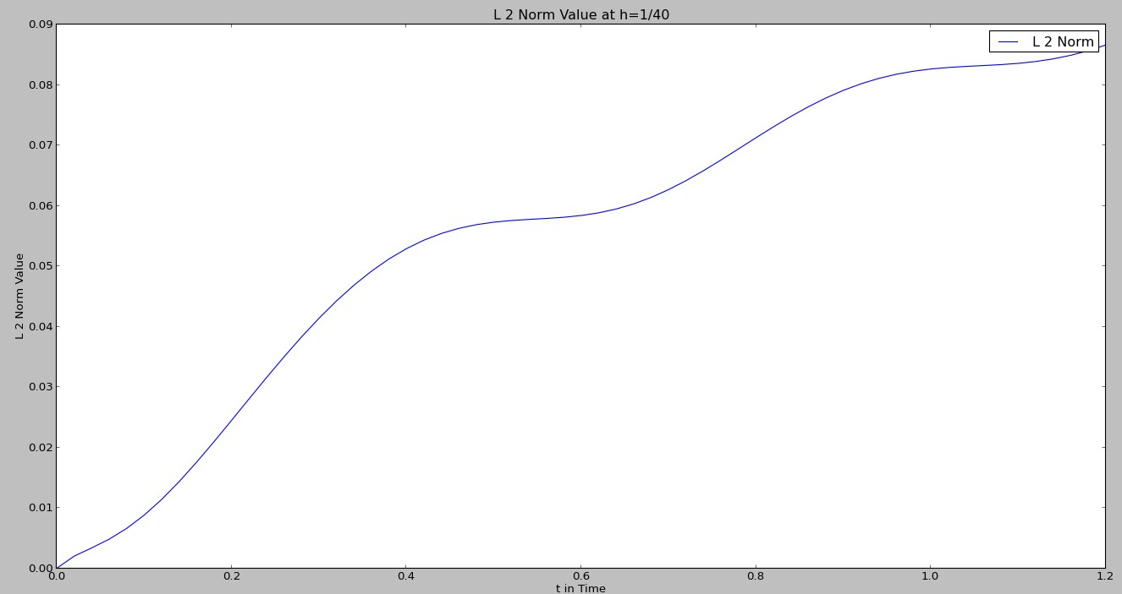

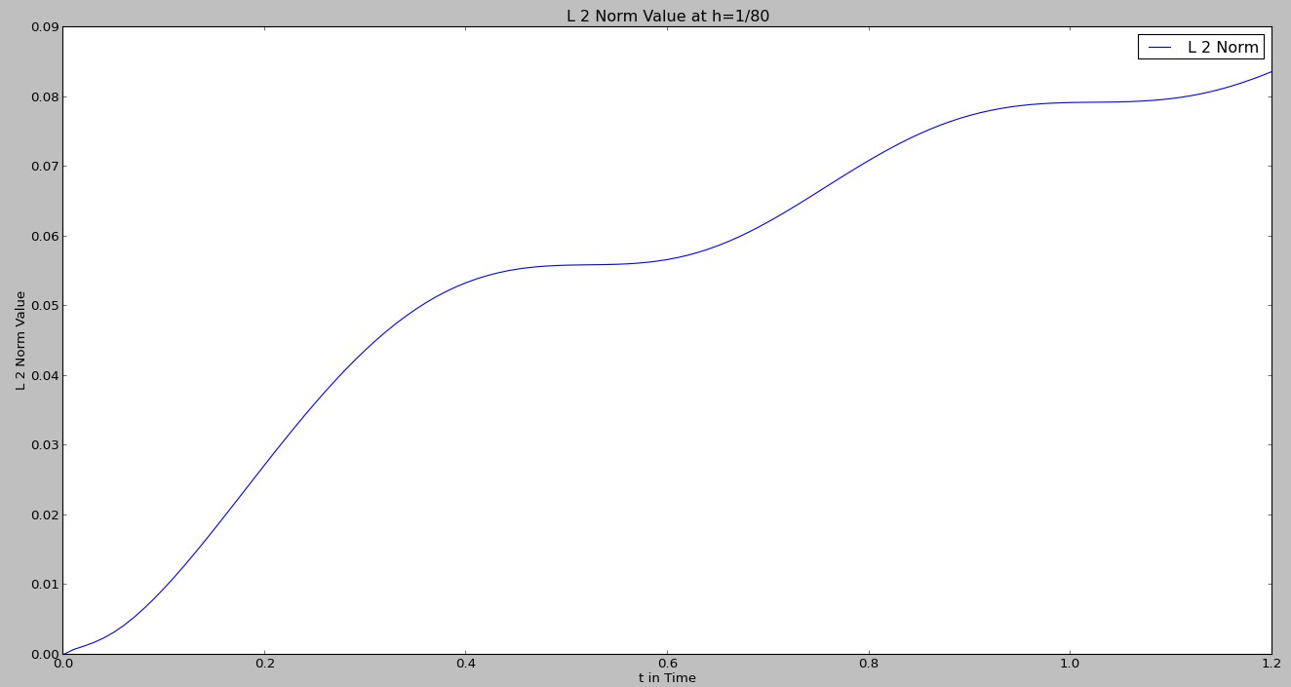

|  |  |  |  |  |
| --- | --- | --- | --- | --- |
| The value of h | 1/10 | 1/20 | 1/40 | 1/80 |
| Max L2 Norm | 0. 2467031 | 0.11418097 | 0.0866677 | 0.0837264 |

|  |  |  |
| --- | --- | --- |
| The Value of h | Error (At time 1.2s ) | Order |
| 1/10 | 0.686 |  |
| 1/20 | 0.256 | 1.46 |
| 1/40 | 0.087 | 1.5 |
| 1/80 | 0.031 | 1.51 |

From the chart we can see that the accuracy order is tending towards 2.